1. 測試內容：

測試 Flow 之 match field:“IPV6_SRC”,“IPV6_DST”是否正確運行。

1. 測試環境架構：

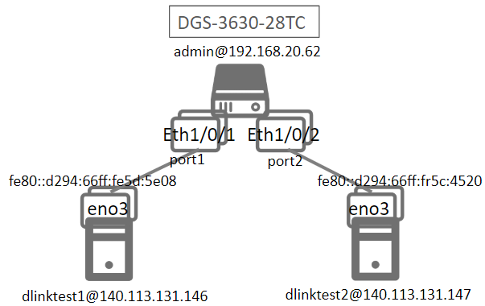

1. 測試環境組態：

* SDN controller: ONOS 1.15.0
* Switch: DGS-3630
* Hosts:
  + ubuntu 16.04.5 LTS
  + dlinktest1(實體機)
    - IPv6: fe80::d294:66ff:fe5d:5e08
    - MAC: d0:94:66:5d:5e:08/64
    - Port: 1
  + dlinktest2(實體機)
    - IPv6: fe80::d294:66ff:fe5c:4520
    - MAC: d0:94:66:5c:45:20/64
    - Port: 2
* Apps:

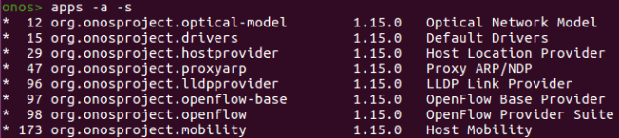

1. 使用之JSON文件：

* Flow Rule: (附檔：IPV6.json)
  + ETH_TYPE為必填欄位

|  |
| --- |
| {  "flows":[  {  "priority":40001,  "timeout":0,  "isPermanent":true,  "deviceId":"of:000078321bdf4000",  "selector":{  "criteria":[  {  "type":"ETH_TYPE",  "ethType":"0x86DD"  },  {  "type":"IPV6_SRC",  "ip":"fe80::d294:66ff:fe5d:5e08/128"  }  ]  },  "treatment":{  "instructions":[  {  "type":"OUTPUT",  "port":"2"  }  ]  }  },  {  "priority":40001,  "timeout":0,  "isPermanent":true,  "deviceId":"of:000078321bdf4000",  "selector":{  "criteria":[  {  "type":"ETH_TYPE",  "ethType":"0x86DD"  },  {  "type":"IPV6_DST",  "ip":"fe80::d294:66ff:fe5d:5e08/128"  }  ]  },  "treatment":{  "instructions":[  {  "type":"OUTPUT",  "port":"1"  }  ]  }  }  ]  } |

1. 測試步驟：
2. ONOS GUI: Flow View



1. Monitor: Using ping tool

* Let h1 ping h2.

|  |
| --- |
| ping6 –I eno3 –c 5 fe80::d294:66ff:fe5c:4520 |

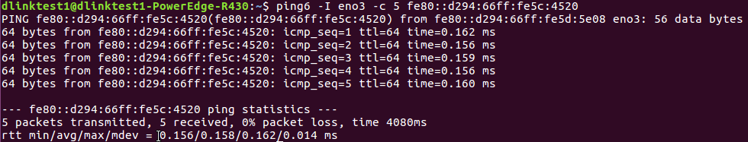

* h2 uses tcpdump to monitor.

|  |
| --- |
| sudo tcpdump –nni eno3 icmp6 |

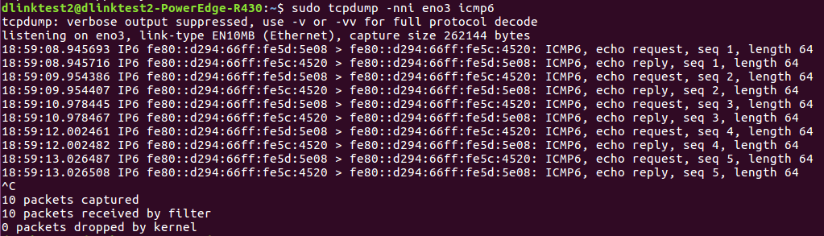

1. 測試結果：

Flow之match field:“IPV6_SRC”, “IPV6_DST”可以正確運行。